

Measure X Project Report

December 2024

Measure X Transportation Projects

North Fremont Bike and Pedestrian Improvement from Casanova to Canyon Del Rey (North Side) Project

a.k.a. the N Fremont “Gap Closure” Project

2024 update

The City partnered with the Transportation Agency for Monterey in a joint application for the Fort Ord Regional Trail & Greenway and the Gap Project for an Active Transportation Program Cycle 7 which was submitted in June 2024. Staff received news in November that the grant application did not make the cut-off threshold for Cycle 7.

2023 update

Final plans, specifications and construction cost estimate were completed this year. The construction cost estimate is $2.8 million and includes a 10% contingency, construction management and engineering during design. The environmental efforts/ CEQA ISMND were approved by each the City of Monterey City Council, as the lead agency, and the Seaside City Council this year. The project design is considered shovel ready, however, the project is not funded for construction or to acquire the necessary permits. The City will continue to look for future funding opportunities.

2022 update

Design progressed throughout the year and is now considered substantially complete. New elements including a decorative guard rail adjacent to N Fremont and reconfigured connection from Casanova Ave to the N Fremont median bike lanes were incorporated. The Casanova Ave reconfiguration will create the shortest path of travel for bicyclists to enter the median:

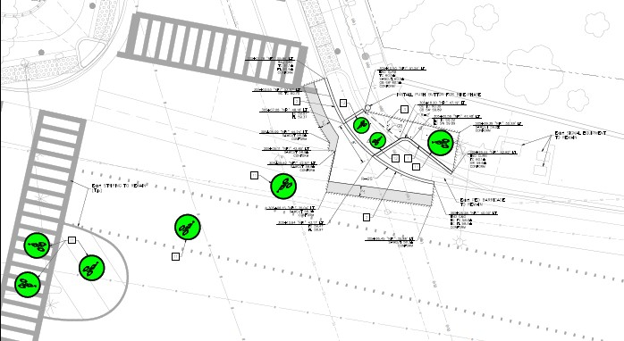

Figure: Casanova Ave Connection

All structural design elements including the pedestrian bridge and foundations and retaining walls were completed. The project construction cost estimate is now approximately $2.3-2.8 million.

The project was unsuccessful in acquiring construction funding in the first round of Clean California local grant program and is ineligible for the upcoming cycle due to not meeting revised underserved community requirements. The City will continue to look for future funding opportunities.

2021 Update

This project is the perfect example of using Measure X funding to support transportation safety and operations improvements to enhance the quality of Transportation in Monterey and Monterey County.

The award-winning N Fremont Bike and Pedestrian Access Project was a great addition to the network of bike paths or trails that people can use to safely walk or bike throughout town. However, that project was grant funding dependent and unable to incorporate (as intended) the segment of Casanova to Canyon Del Rey. This has left a temporary connection “gap” where no sidewalk nor bike lane exist on the north side.

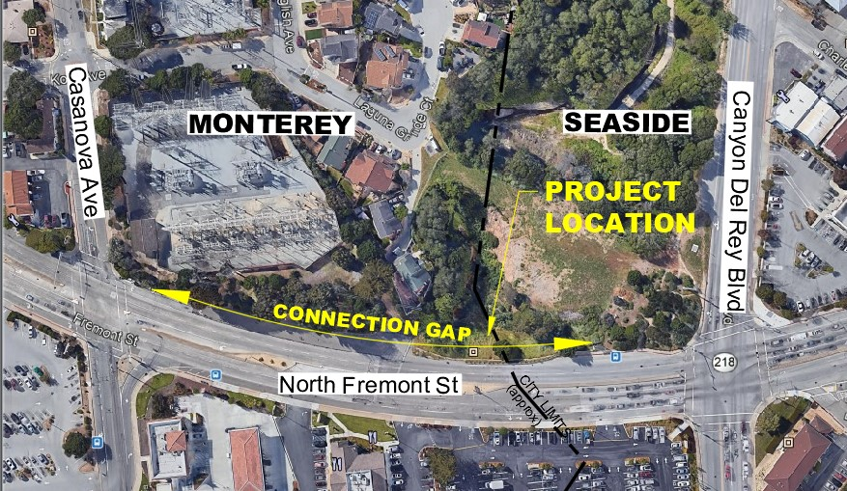

Figure 1: Project Location. “Connection Gap”

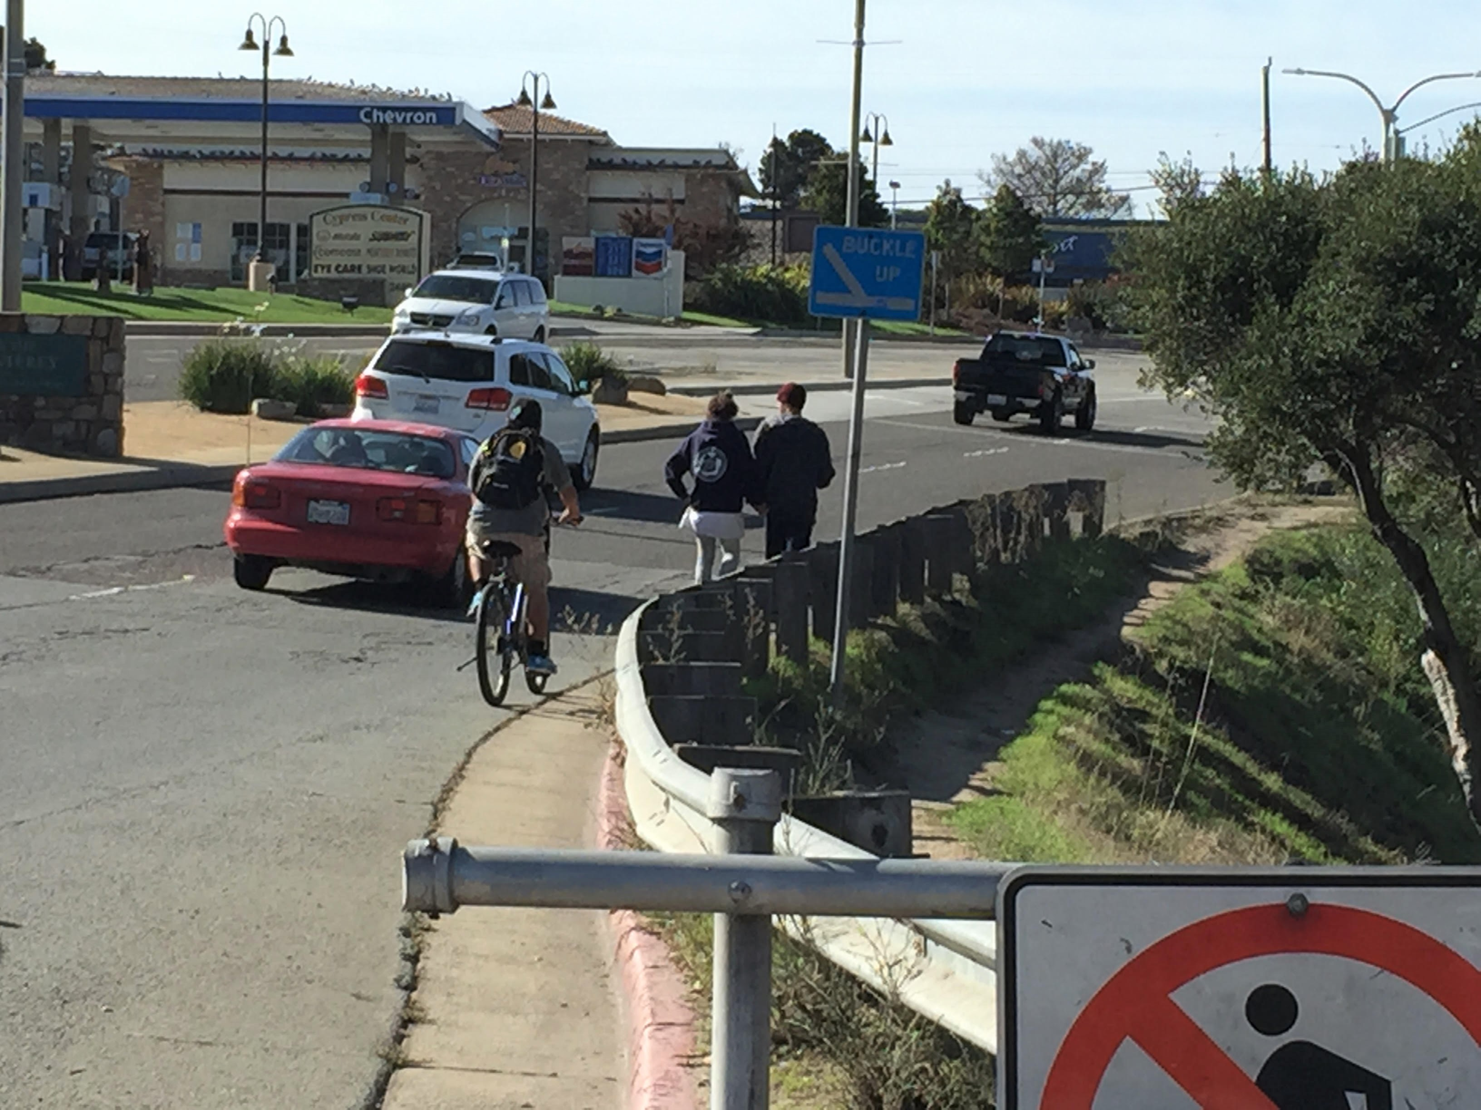

Figure 2: Existing Condition

The block presents several challenges such as environmentally sensitive areas, steep slope/ elevation changes, right-of-way width constraints, utility conflicts, as well as being a multi-jurisdictional area (Monterey, Seaside and Caltrans). City staff and consultants have analyzed the challenge and determined the most cost effective solution to be a pedestrian bridge.

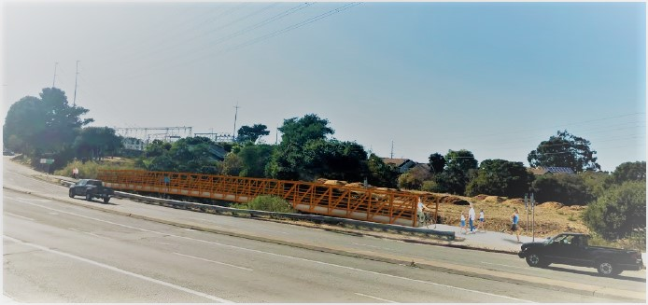

Figure 3: Concept Rendering

The bridge will provide a Class I mixed-use path that will connect users from the N Fremont corridor to the much larger future FORTAG network. The bridge will be a pre-fabricated, pratt truss style structure, with ADA-compliant concrete decking. We anticipate steel cables to match the aesthetics of the constructed N Fremont bike lanes as well as pedestrian-level lighting, but the design is ongoing (and input is welcome). The construction cost estimate is $1.5-2M. The current project is funded for the project design only, not construction. The goal is to have a completed design, “shovel ready” project by the end of the year, which will put the project in a position to apply for grant funding to close the gap.

## Project Funding

Account 1 (35c1851)(MEASURE X): $71,038.76

Account 2 (37n1950)(NCIP): $307,675.30

**Total: $378,714.06**

## Before & After Photos

Before, 2015