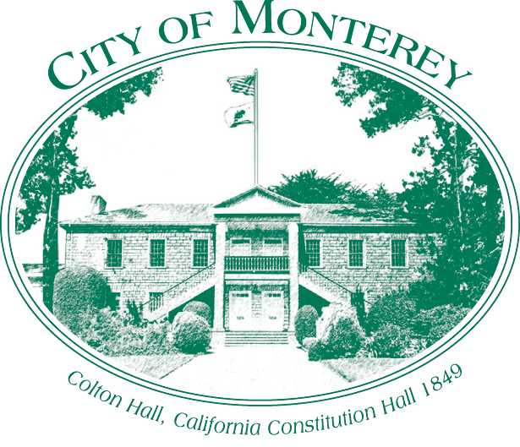

Measure X Project Report

December 2024

Measure X Transportation Projects

Citywide Speed Survey Update

This project is the prime example of using Measure X funding to support transportation safety and operations improvements to enhance the quality of Transportation in Monterey and Monterey County.

## Project Description

In California, speed regulations are based on the basic speed law that states, “No person shall drive a vehicle upon a highway at a speed greater than is reasonable or prudent having due regard for weather, visibility, the traffic on, and the surface and width of the highway and no event at a speed which endangers the safety of person and property.” This applies to all roadways, even those with posted speed limits.

Under California Law, the maximum speed limit is 65 miles per hour (mph). All other speed limits are called prima facie limits, which are considered by law to be safe and prudent under normal conditions. Some prima facie limits are established by State law, such as:

* 25 mph speed limit in residential districts
* 25 mph speed limit in school zones when children are present
* 15 mph speed limit in alleys and railroad crossings

Speed limits between 25 mph and 65 mph and above 65 mph must be established by the California Vehicle Code (CVC) Sections 40801 and 40802. These CVC sections require that traffic speed limits are established by an “Engineering and Traffic (E&T) Survey” or Speed Survey. The Speed Surveys must consider prevailing vehicle speeds, collision frequencies, roadside development, and other conditions not readily apparent to drivers.

CVC Sections 40801 and 40802 require that Speed Surveys be conducted every five (5) years to establish the prima facie speed limits before enforcement by radar can be conducted. The surveys can be extended to seven (7) years provided the City’s police officers have completed a 24-hour radar operator course. The City of Monterey is on a seven (7) year cycle.

Since 2017, several laws have been adopted in California which give local agencies greater flexibility in setting speed limits in order to potentially reduce fatal or serious injuries, such as AB43. Additionally, Caltrans released the latest revision of the California Manual on Uniform Traffic Control Devices (CAMUTCD) which provides cities with greater guidance on how to set speed limits with the latest changes to the law.

## Project Update

The City collected traffic data in May 2023, the new speed ordinance was adopted in March 2024 and went into full effect in May 2024. The 2024 speed survey made a recommendation to lower six speed limits:

1. Aguajito Road between Mark Thomas Drive and Monhollan Road from 40 to 35 mph
2. Del Monte Avenue between East City Limit and Sloat Avenue from 40 to 35 mph
3. Del Monte Avenue between Sloat Avenue and Camino El Estero from 35 to 30 mph
4. English Avenue between Del Monte Avenue and Highway 1 NB Ramps from 30 to 25 mph
5. Fairground Road between Garden Road and Airport Road from 35 to 30 mph
6. Viejo Road between Soledad Drive and City Limits from 40 to 35 mph.

## Project Funding

Account 1 (CIP2012)(MEASURE X): $71,313.00

Total: **$71,313.00**

## Before & After Photos

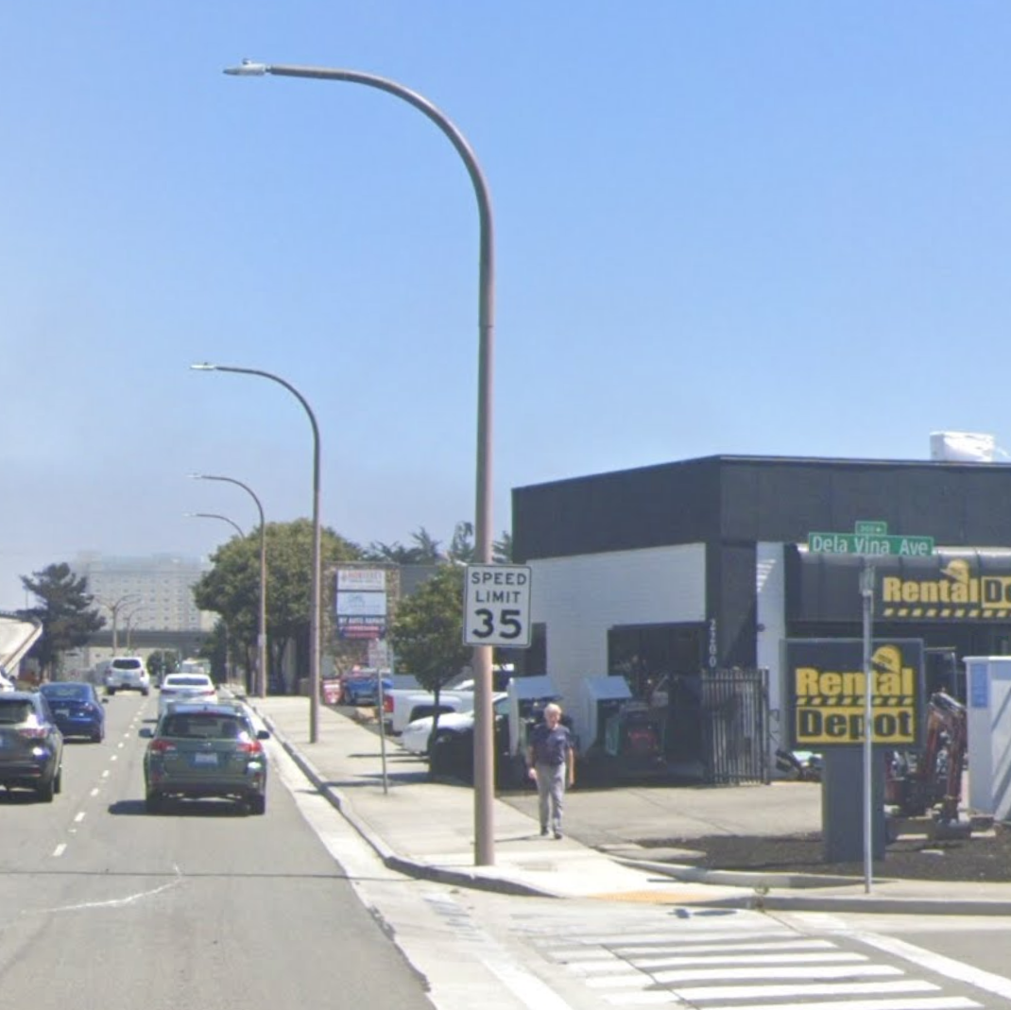

*Del Monte Avenue at Dela Vina Avenue Before & After*