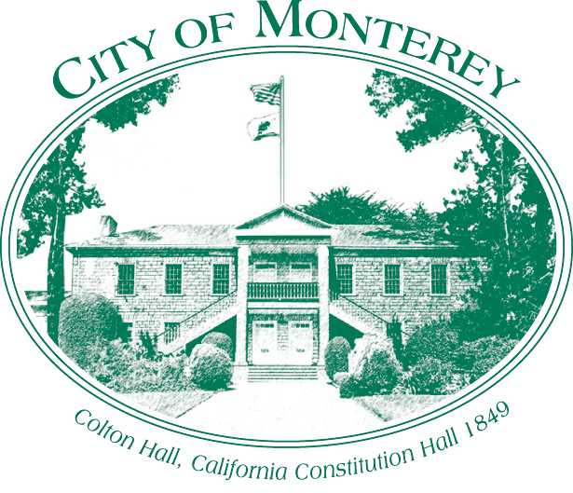

Measure X Project Report

December 2024

Measure X Transportation Projects

Lighthouse Avenue and Prescott Ave Crosswalk Removal Project

This project is the prime example of using Measure X funding to support transportation safety and operations improvements to enhance the quality of Transportation in Monterey and Monterey County.

## Project Description

The City continuously looks for opportunities to increase pedestrian safety. The presence of crosswalks is used as a guide for pedestrians to signify the best crossing location and a way to communicate crossings to motorists. As shown in Attachment 2, there are currently four marked controlled crossings at the intersection of Lighthouse and Prescott.

The south crosswalk, crossing Lighthouse Avenue, is proposed to be removed. The location of the crosswalk, in combination with the grade on Prescott Avenue, and the angle of the sun and glare from surrounding building during the fall season, from late October to mid-December, provides visibility concerns with the conflicting movement of left turning vehicles from Prescott turning onto southbound Lighthouse Avenue. For this brief period of the year, the south crosswalk does not meet the intent of a marked crosswalk, which is to signify the best crossing location and a way to communicate crossings to motorists.

The removal of the crosswalk also has other benefits to pedestrians and drivers. The intersection of Lighthouse and Prescott experiences a large volume of right turns from Prescott onto southbound Lighthouse (from the adjacent neighborhood and Presidio of Monterey) as well as a large volume of left turns from Prescott onto Lighthouse southbound (from the secondary parking garage exit and Cannery Row). When a pedestrian is crossing, the drivers that are making a right turn from the neighborhood and drivers making a left turn must wait until the pedestrian has cleared the crosswalk.

This can create long delays in clearing Prescott and creates a condition in which drivers block the intersection. This delay causes frustration, and it can lead to low tolerance on the part of drivers waiting for pedestrians to clear the crosswalk before proceeding.

Removing this crosswalk will greatly benefit traffic signal operations as well as minimizing conflict between drivers who do not wait for pedestrians to clear the crosswalk before proceeding through the intersection. Pedestrians will be able to cross the intersection by using the remaining north crosswalk on Lighthouse at Prescott. While it may not be as convenient, it is a safer crossing.

## Project Update

The project started in December 2022, but was delayed due to scheduling issues and the 2023 storms and fixing the resulting storm damage. This project was completed in August 2023.

## Project Funding

Account 1 (CIP2012)(MEASURE X): $11,650.00

Total: $11,650.00

## Before & After Photos

Before, 2021

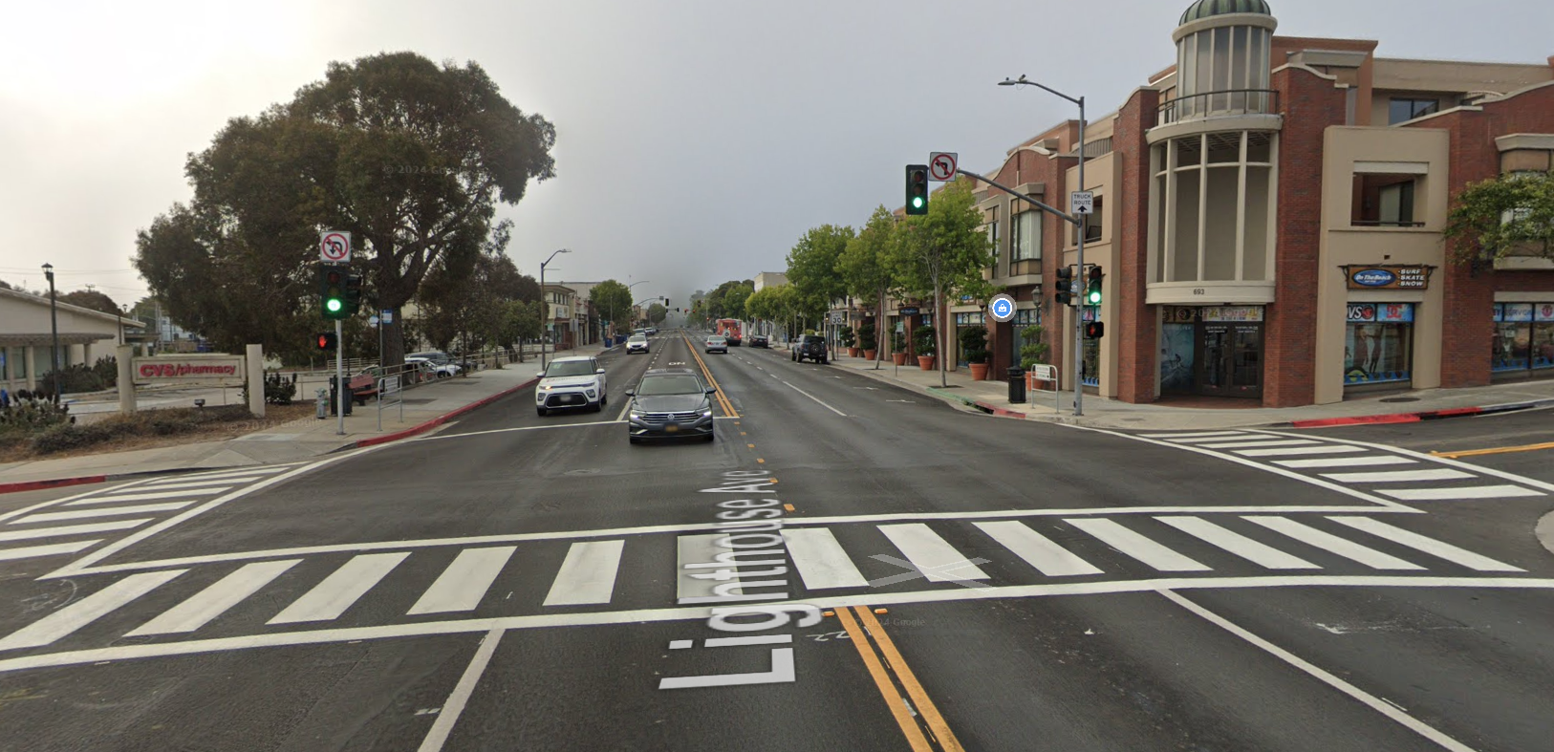

After, 2024