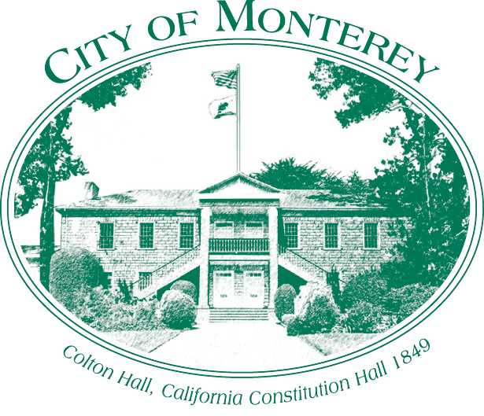

Measure X Project Report

December 2024

Measure X Transportation Projects

ATP/RSTP Grant Application for Del Monte/Washington and Del Monte/El Estero

This project is using Measure X funding in combination with the Active Transportation Program to enhance transportation safety.

## Project Description

The intersections of Del Monte Ave at Washington and Del Monte at Camino El Estero are intersections heavily utilized by pedestrians and bicycles that must weave through heavy congestion and cars queueing in their crossing areas. Pedestrians and bicycles also face long crossing distances and wait times due to the heavy congestion in the corridor. Del Monte also has frequent crossings of larger groups of pedestrians, the intersection of Del Monte and Washington has pedestrian crossing calls activated 75% of day. Del Monte Avenue experiences severe congestion as it has a high demand of 42,000 vehicles per day, this is about 76% of traffic carried on Highway 1.

Crossing along Del Monte is precarious with long crosswalks between 100‐120 feet in length that are often blocked by vehicles. There are currently no bicycle connections or facilities on Del Monte Avenue, Washington Street or Camino El Estero and bicyclists have no means of crossing Del Monte Avenue from the recreation trail to their final destination. Bicycles must dismount and cross narrow crosswalks and ramps competing with pedestrians.

Over the course of a day it is estimated that 4,600 pedestrians and 540 bicycles utilize the two intersections daily, however during peak tourism season and special events the numbers can be much higher.

This project provides great benefits and access for pedestrians and bicyclists for those who utilize the recreational trail for commuting and recreational purposes. The expected benefits include increased biking and walking trips to improve public health, enhanced mobility for non‐motorized users to be more widely accessible for users of all abilities, and reduced vehicle trips to reduce greenhouse gas emissions. All benefits apply to disadvantaged communities who utilize the trail to commute or for recreation purposes. The project provides access to major destinations in the City such as Monterey Downtown, The Wharf, Cannery Row, and El Estero Park.

The improvements would make the crossings at the two intersections less stressful for bicycles and pedestrians by shortening distances, providing median refuges and higher visibility. Additionally, ADA improvements and safety lighting are included.

## Project Update

Funding was used to bring the project to 30% design and apply for Active Transportation Program funds to maximize the City’s ability to deliver the best possible project to residents and visitors.

The City applied in 2018 to the Active Transportation Program (ATP) Cycle 4 Call for Projects and did not receive funding. The City applied again to Cycle 5 in 2020, reducing the scope and focusing on Del Monte and Washington. The Cycle 5 application scored higher, but still did not meet the threshold for funding which was a score of 92 out of 100 points.

The City decided to reevaluate the intersection of Del Monte and Washington and look for a lower cost alternative and alternative grant funding sources for the final design and construction of the intersection. This alternative has a single stage crossing and has less median improvements and landscaping than the ATP grant application alternative. This alternative does not remove the right turn exiting from the southbound Washington approach and does not include separate crosswalks for bikes - “crossbikes”.

The City is continuing to look for funding sources for the intersection improvement with the lower cost alternative.

In 2022 the City applied again for an Active Transporation Program Active Transportation Program (ATP) Cycle 6 Call for Projects and did not receive funding. The City increased the scope from Cycle 5 to consider the intersection of Camino El Estero and scored lower at 67 points. The cut off score was 78 points and 65% of the projects were Safe Routes to School Projects, this project did not include a Safe Routes to School component.

In 2023 the City applied for a Regional Surface Transportation Program (RSTP) grant to design and construct this project, the City was not successful in this grant application. The City is moving forward with fair share RSTP funds to fund the design of the Project. The City is hoping to complete PS&E with fair share funds to have a shovel ready project.

The City is considering re-applying, with a shovel ready project, for both an ATP grant in a future funding cycle and continuing to consider alternative funding sources for a lower cost alternative. The City has successfully implemented two ATP grant funded projects, the North Fremont Bicycle and Pedestrian Safety and Access Improvement project and the Active Transportation/Demand Management Plan project. The ATP grant program has long been considered an underfunded and over-subscribed funding source even with the annual commitment of nearly a billion dollars for the State as part of SB 1.

The City has been working on developing a Request for Proposal for the Plans, Specifications, and Estimates (PS&E) stage of the Project with the fair share component of the Regional Surface Transportation Program. The City anticipates releasing a Request for Proposals (RFP) in the summer of 2025.

## Project Funding

Account 1 (35C1851) (MEASURE X): $56,170.00

Total: $56,700.00

## Before & After Photos

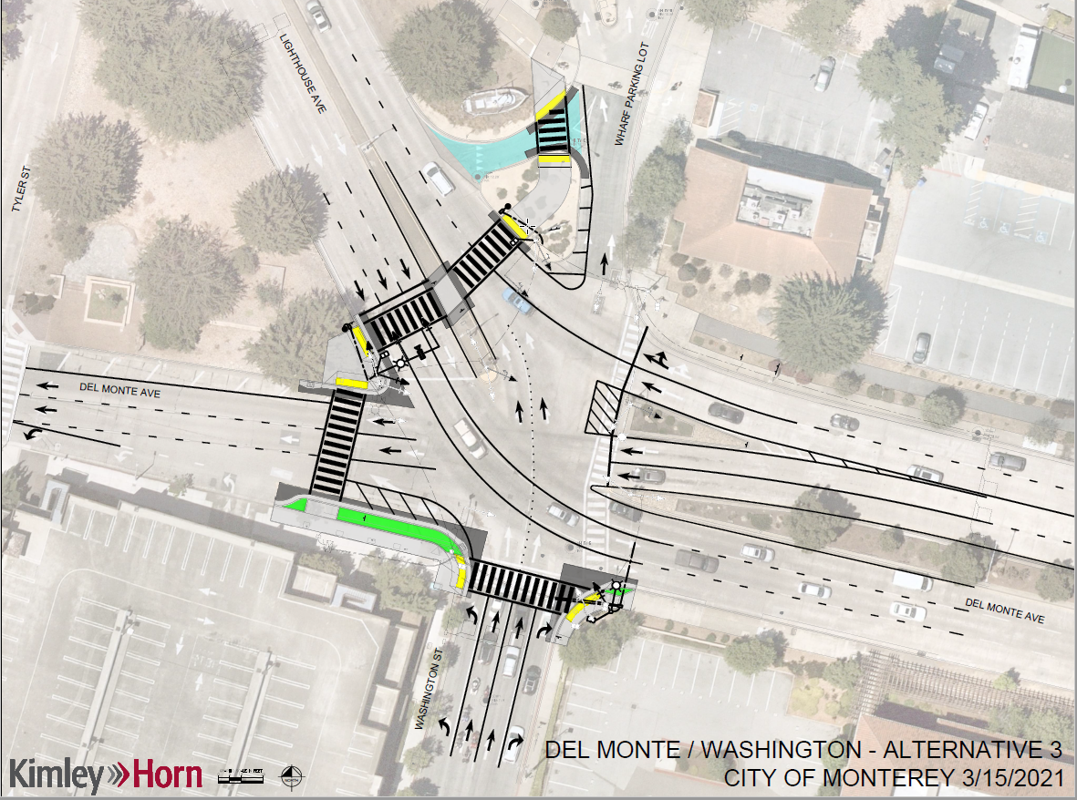

*Del Monte/Washington Alternative*



*ATP Cycle 4 & 6 Del Monte/Camino El Estero Design*



*ATP Cycle 4 & 6 Del Monte/Washington Design*