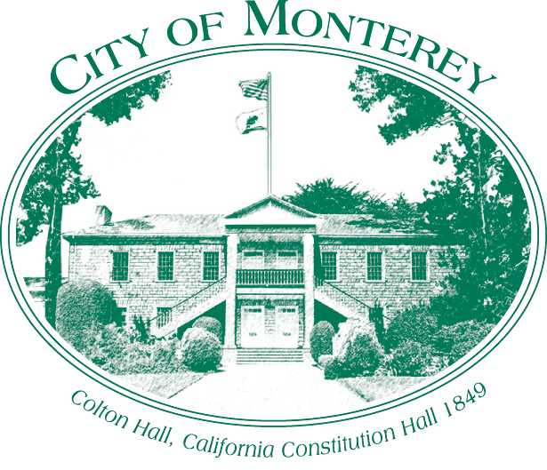

Measure X Project Report
December 2024

Measure X Transportation Projects
Citywide Wayfinding Sign Program, Phase 1, Project
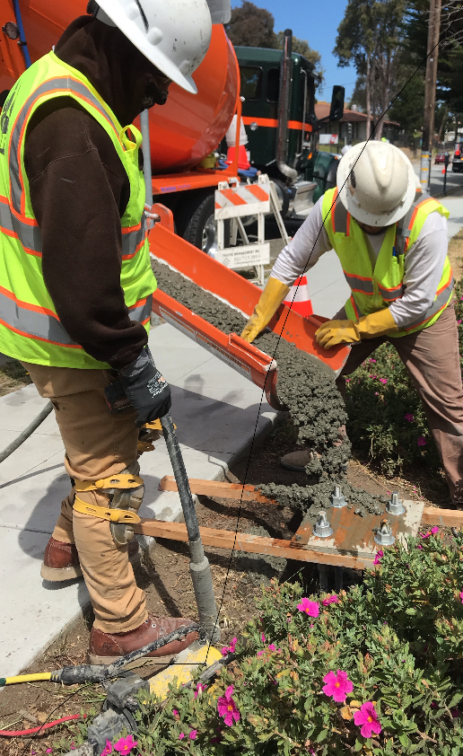
This project is the perfect example of using Measure X funding in addition to Local funds to enhance the quality of Transportation in Monterey and Monterey County.

Project Description
The City of Monterey is a major tourism destination on the peninsula. The City has many popular destinations such as Cannery Row, Monterey Bay Aquarium, Fisherman’s Wharf and Customs House Plaza. The Monterey Bay Aquarium alone experiences over 1.9 million visitors in a typical year.

The City is improving its wayfinding experience by updating and creating a comprehensive wayfinding sign program which also includes bicycle and pedestrian wayfinding. The first phase is the Parking Phase which directs vehicles to the City’s public parking Lots and garages. This first step is also in line with the City’s “Park Once” program which encourages visitors to park once and use the free MST Trolley or walk between Cannery Row and Downtown to reduce congestion between Downtown and Cannery Row.

Phase 1 of the project commenced in April 2020 and was completed in June 2020.

Project Updates
Completed improvements include:

61 new wayfinding signs, including 39 vehicular signs and 22 pedestrian signs
- Work consisted of installing new foundations for sign poles, fabricating wayfinding signs and installation of wayfinding signs.

As part of the project the City has created an article on the Traffic Engineering City Webpage, which shows sign types and sign locations for current and future phases.
https://monterey.org/city_hall/departments/traffic_engineering/index.php (link updated to reflect new City website)

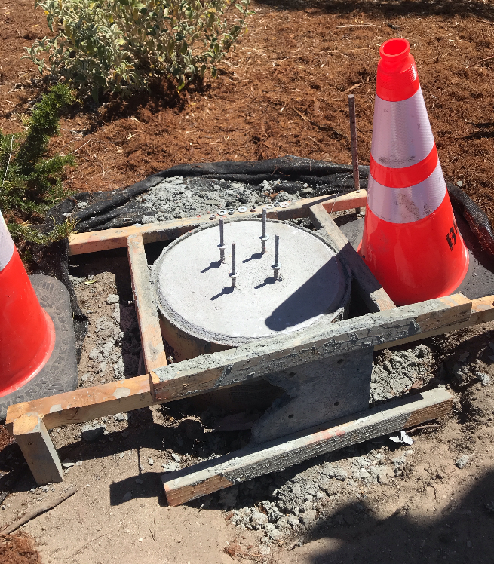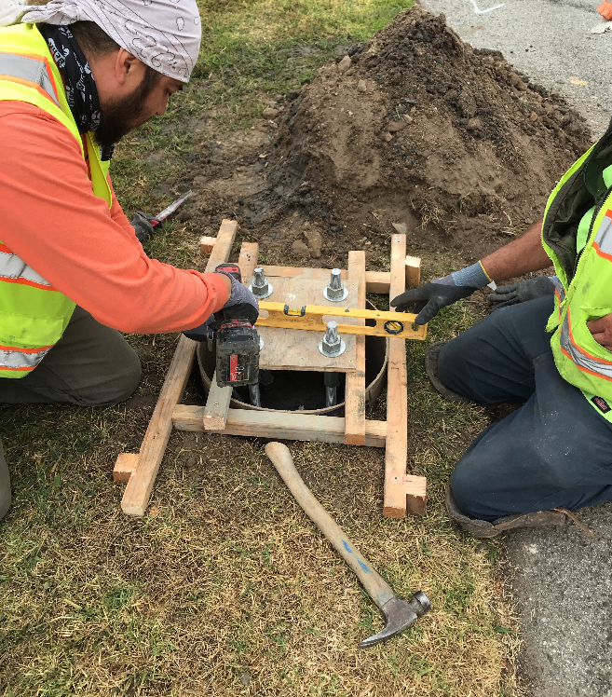
Wayfinding sign foundation construction

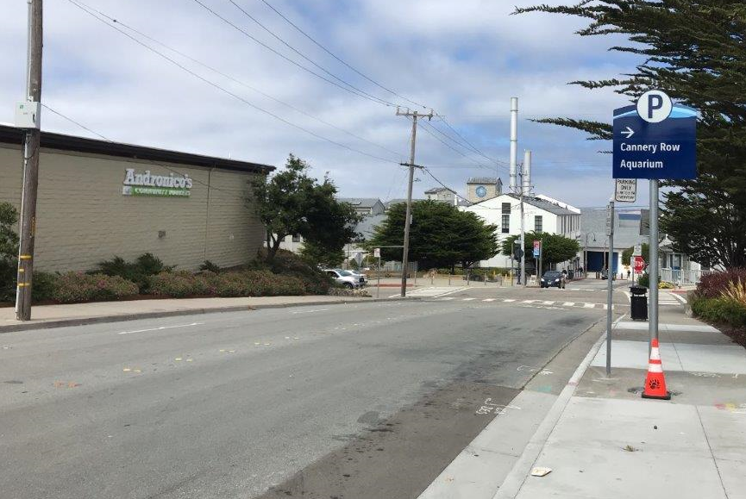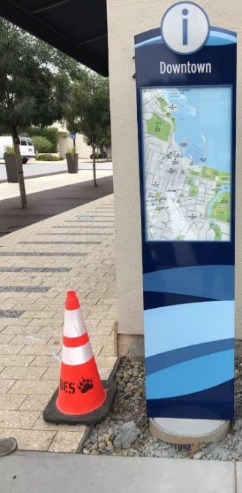
Example of signs installed during Phase 1

In progress improvements include:

Phase 2 of Wayfinding signs which is new wayfinding signs, including 39 vehicular signs and 22 pedestrian signs
- Work consisted of installing new foundations for sign poles, fabricating wayfinding signs and installation of wayfinding signs.

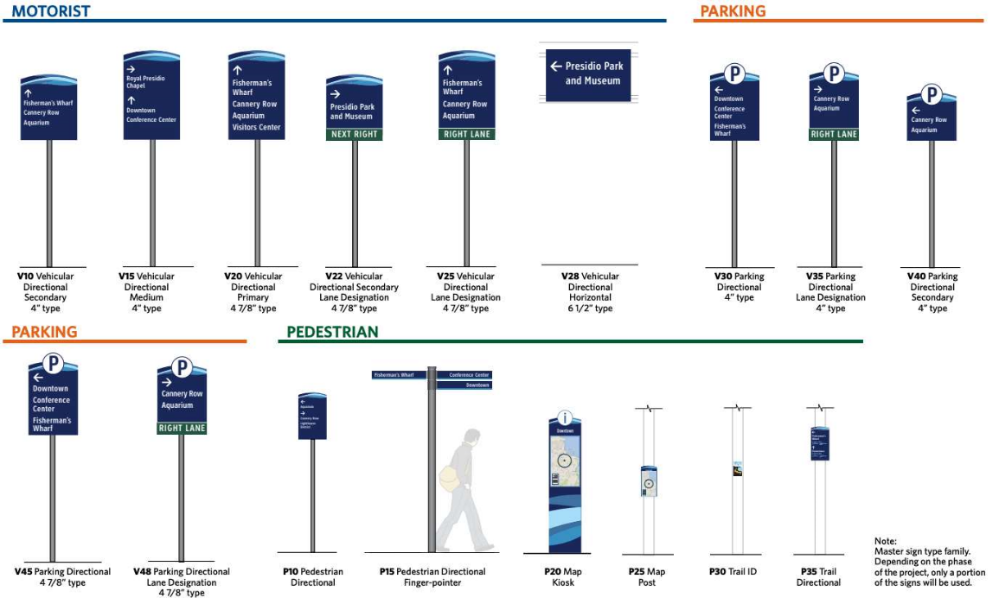
Examples of Wayfinding Sign Types for All Phases
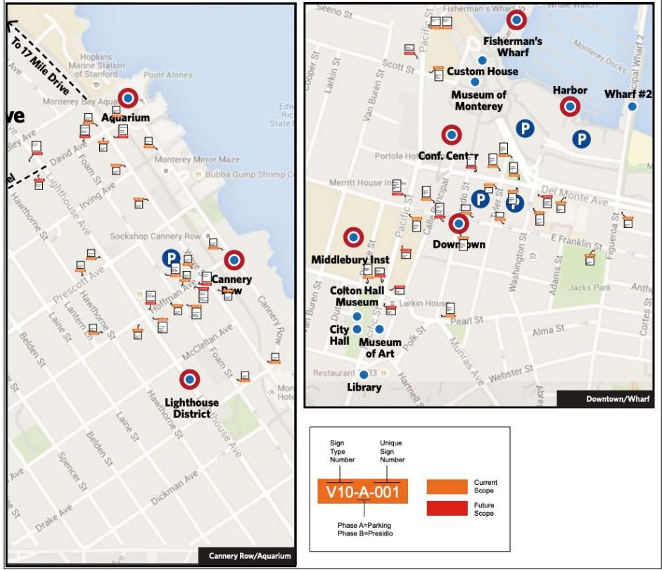
Map of Existing and Future Phase Sign Locations

Contract executed with on-call contractor to furnish and install poles, structural drawing submitted and approved for sign types which were not included in Phase 1 to ensure that signs will sustain high wind events. A set of standard details was developed for Phase 2 signs, an example of options is shown below. The majority of the new poles were installed in May 2022, a remaining five poles require a Caltrans Encroachment permit which Staff is working on.
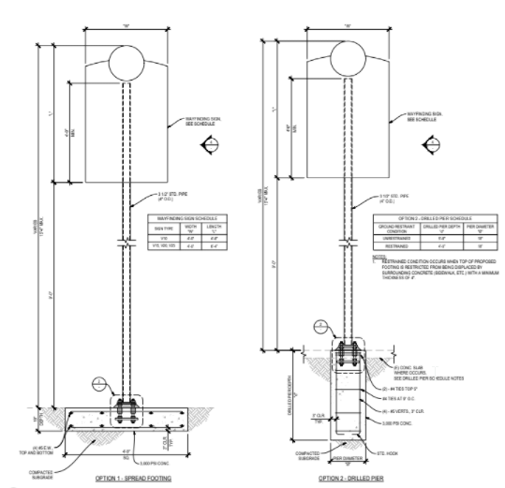
Wayfinding Standard Details for Phase II signs

In April 2022, the City released an invitation to bid for the Wayfinding Sign Fabrication, Phase 2 project and the contract was awarded to Ampersand Signs on June 21, 2022. The contractor mobilized and has begun fabrication on the Phase 2 signs, which are anticipated to be installed in 2023. No funds were expended in this fiscal year; however, City Staff continued to work on the project.
In 2023, Phase II wayfinding signs were fabricated and delivered. The majority of vehicular wayfinding signs were installed in May 2023, with six that require Caltrans encroachment permits remaining. The Phase II Pedestrian Wayfinding signs were delivered in September and will be installed by City Maintenance Staff in Phases as they remove existing old Wayfinding signs in 2024. All of the old Wayfinding signs have been removed as of 2024, Staff are continuing to install these off peak season to reduce the impact to tourism.

Project Funding

Account 1 (34c0732) (CIP): $59,888.51
Account 2 (CIP2012) (MEASURE X): $109,051.49
Total: $168,940.00

Before & After Photos
Example Before & After photos at Wave Street between David Ave and Irving Ave.
