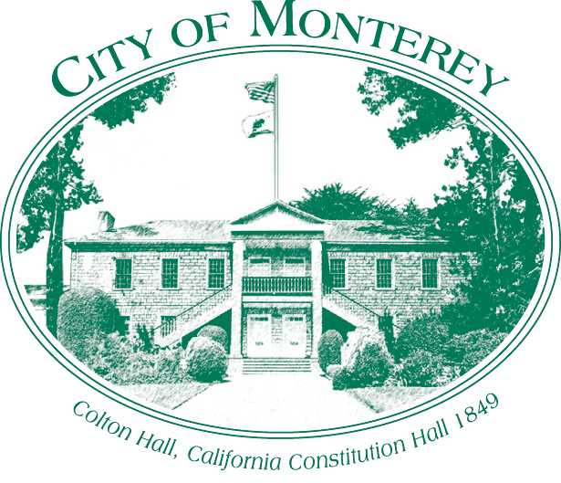

Measure X Project Report

December 2024

Measure X Transportation Projects

TAMC Traffic Counts

This project is the prime example of using Measure X funding to support transportation safety and operations improvements to enhance the quality of Transportation in Monterey and Monterey County.

## Project Description

The Transportation Agency for Monterey County has a biannual regional traffic counts program that monitors the level of service on regional roadways. This information provides continuous updates to the local Metropolitan Planning Organization (MPO), the Association of Monterey Bay Area Government’s regional travel demand model. Count locations are on the county’s regionally significant routes and include several locations in and around the City of Monterey. Due to the partnership between TAMC and the City of Monterey as local public agency partners, the City is able to piggyback onto the count program at a significant cost savings.

## Project Update

The City of Monterey periodically requests counts in addition to what TAMC collects for their count program. These counts are used to supplement the counts for grant applications and to inform transportation projects. For example, staff had additional counts collected on Calle Principal and is currently looking at the feasibility of a multimodal infrastructure project along Calle Principal. The counts will be used for future grant applications and to inform design decisions in the project process. The Calle Principal Multimodal Improvement Feasibility Study will be reported in 2025 Measure X reports as it kicked off in November 2024 in FY24-25.

## Project Funding

Account 1 (CIP2012) (MEASURE X): $2,523.00

Total: **$2,523.00**

## Photos

*N/a*