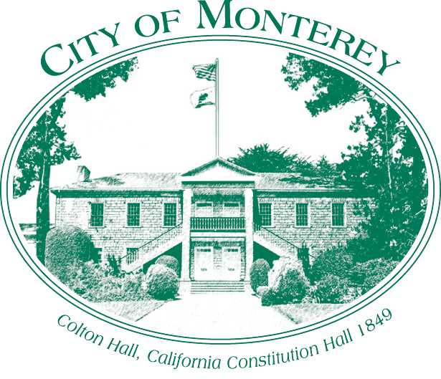

Measure X Project Report

December 2024

Measure X Transportation Projects

Crossroads Software Improvement

This project is using Measure X funding to enhance transportation safety in the Monterey Region.

## PROJECT DESCRIPTION

As part of the City of Monterey Police Department’s effort to improve its Police Records Management System, Measure X funds were used to cover some costs of integrating and updating the Crossroads system.

The City of Monterey has used Crossroads Collision Database Analytics System for several years now, Crossroads is a commonly used program by public agencies nationwide. Crossroads Collision Software allows Cities to produce traffic collision and citation reports which can be used to understand collision patterns and trends. The Public Works Department uses Crossroads Collisions in grant applications, traffic studies, speed surveys, and public outreach.

The Police Department expanded the use of Crossroads to utilize it for Citation and Collision Report writing. The Citation Writing System will include software for electronic citations that offer more efficient input of data, electronic signature and driver license bar code reading.

Project Update  
The Crossroads upgrade was completed summer of 2023.

## Project Funding

Account 1 (CIP2012)(MEASURE X): $67,800.00

**Total: $67,800.00**