

Measure X Project Report

December 2024

Measure X Transportation Projects

Recreation Trail Counter Installation Project

This project is the prime example of using Measure X funding to support transportation safety and operations improvements to enhance the quality of Transportation in Monterey and Monterey County. This project could also potentially help with gathering data necessary for grant applications.

The City installed two recreation trail counters in October 2023, the traffic counters selected are the RidePod BP by MetroCount. This is the only vendor that had all of the data collection features required. The RidePod BP collects bike, pedestrian and e-scooter counts, bike speed, direction, gap & headway, and clusters. This traffic counter does not have any speed feedback capabilities, which was desired, but no vendors have this capability at this time. The regular radar speed feedback signs we use in neighborhoods cannot be used on the Rec Trail as they are not set up for recreation trails and cannot distinguish between pedestrians and bicycles which would skew the data.

The two locations where the counters were installed are Location 1 placed on Presidio Curve which has high volumes and Location 2 between Park Ave and Sewer Treatment Plant Rd which can have higher bike speeds.

The recreation trail counters were installed to help the City with policy decisions regarding the use of the Recreation Trail. The popularity of the trail, popularity of e-bikes and change in law regarding e-bikes on Class I facilities have changed the characteristics of trail users in recent years. The City wanted to better understand the volume and speed of pedestrians, bicycles and scooters in the City. The Public Works and Police Department have been working towards understanding the behavior of trail users in order to handle trail conflicts such as speed and reckless bicycling. The results of the study could result in a bicycle speed limit or changes to Monterey City Code.

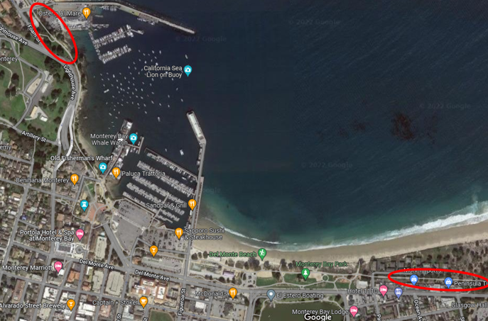

*Bicycle Counter Locations*

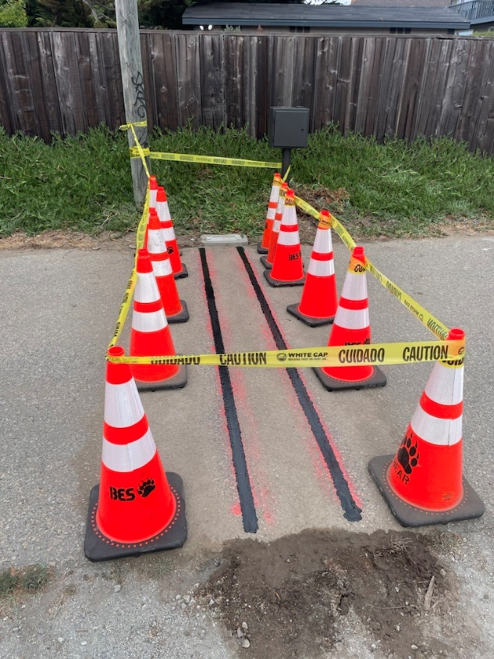

*Installation of the Bicycle Counters at Location 2, 2023*

## Project Update

In May 2024, Staff discovered vandalism at the bicycle counter at Location 2. Staff worked with the Police Department and Bear Electrical to investigate and replace the parts to put the counter back in working order. In October 2024, staff was authorized to proceed with the replacement and are working on replacing the stolen parts and adding further security features.

## Project Funding

Metrocount Equipment Purchase (CIP2012)(MEASURE X): $16,520.00

Bear Electrical Equipment Installation(CIP2012)(MEASURE X): $24,950.00

Bear Electrical Equipment Replacement(CIP2012)(MEASURE X): $650.00

Total: **$42,120.00**