

Measure X Project Report

December 2024

Measure X Transportation Projects

Marina Parking Lot Improvement Project

This project is using Measure X funding in combination with other funding sources to enhance transportation safety.

## Project Description

The Marina Parking Lot Improvement Project includes a major pavement rehabilitation treatment to extend the useful life of the pavement. Additionally, the City is changing parking pay stations and combining the Waterfront and Marina Parking Lot into one large surface parking lot. This project will also improve parking circulation by combining the two existing parking lot and reconfiguring the Marina Lot, by changing the circulation with the objective of reducing the number of vehicles circulating and idling in the parking lot. The Boat Trailer Parking spaces are also being reconfigured as the Marina Parking Lot serves as the boat launch area. ADA improvements are also included in the project to improve access to the businesses at Municipal Wharf 2.

Other major utility improvements are the installation of safety lighting both in the parking lot, trail and entrances to provide better lighting throughout the site, which is utilized nearly all times of day. Additionally, this provides opportunity to improve existing underground utilities such as storm drain and sewer system infrastructure. With any major parking surface lot project, stormwater quality improvement is incorporated into the parking lot in landscaping features which include biofiltration and improve aesthetics of the Marina lot.

As a result of the parking lot reconfiguration to combine the lots and improve circulation, the City found an opportunity to relocate the recreational trail crossing and implement raised crossing which improve pedestrian and bicycle visibility and access.

This Project is a part of the long-term planning effort to improve circulation, connectivity and access in the Waterfront area. In 2019, the City completed construction of the Waterfront Parking Lot and the City began working on the design of the Marina Parking Lot which covers the area bounded by Washington Street and Figueroa Ave. City Staff presented these concepts to the public at three City Council Meetings (June 2021, June 2022, and November 2022) and at a TAMC Bicycle and Pedestrian Committee Meeting in January 2022. In November 2022, the City awarded a contract for construction of the Marina Parking Lot. The construction began in January 2023 and was delayed by the 2023 storms and then by utility relocation issues. The project construction was completed in October 2023.

Measure X provided funding for the relocation of the Recreation Trail, enhancements to the Recreation Trail Crossing, and lighting improvements for the Recreation Trail.

A major challenge was to improve circulation through the now combined Marina and Waterfront Parking Lot areas most of the drivers want to leave the lot via Figueroa and turn left onto Del Monte Avenue. During high-traffic periods (summer weekends especially), there are long lines of traffic waiting to exit the parking lots. The physical distance between the Marina Lot exit lane and Del Monte Avenue limits the number of vehicles that can turn left during a single traffic signal cycle, and often drivers were "trapped" behind the Dust Bowl waiting for multiple signal cycles to turn onto Del Monte Avenue.

Drivers perceived that they were being held up from turning onto Figueroa Street because of pedestrians and cyclists who were using the Rec Trail crossing at Figueroa St. Even though the signal was green at Del Monte, drivers could sometimes not get to the intersection because of this Rec Trail conflict, and often, by the time drivers did reach Del Monte Ave, the cycle had ended because the system did not detect oncoming vehicles. Drivers became extremely frustrated with the delay, resulting in verbal abuse to trail users, drivers blocking the trail with their vehicles, and near misses between drivers and pedestrians and cyclists.

To improve the situation, we have relocated the Rec Trail to the opposite side (north) of the vehicular exit aisle to eliminate this multifaceted conflict. Although there are now more Rec Trail crossings, each crossing has less conflicting vehicle traffic than the single former trail crossing did. Two of these crossings are single lane, one-way crossings, so trail users now only need to look in one direction for on-coming traffic.

In the prior configuration, all of the vehicles leaving both parking areas who wanted to leave via Del Monte Ave eastbound had to cross the Rec Trail at this one location. Now, each crossing will see only a portion of the total traffic. Now, only vehicles exiting the Commercial Wharf will cross the Figueroa Rec Trail Crossing in the exiting direction - all of the vehicles entering the parking area will continue to use Figueroa St. The new configuration also allows Waterfront and Marina Parking Lot users to exit at Washington Street if they are heading toward New Monterey - before, Marina Parking Lot users could only exit via Figueroa St due to the gates on the Waterfront Lot, eliminating at least a few more conflicting vehicles.

Another benefit to relocating the Rec Trail was the elimination of a multilane threat- where one vehicle stops for a pedestrian to cross but another vehicle in an adjacent lane does not see the pedestrian until it is too late. Although it is striped as a single southbound (toward Del Monte) lane, it effectively becomes two southbound lanes during peak congestion times due to the width of the lane (necessary for large vehicles, buses and commercial vehicles) and the number of drivers trying to exit at the same time.

## Project Update

The project achieved substantial completion in October 2023 and final project paperwork is in process.

## Project Funding

### Rec Trail

Account 1 (CIP2005) (CIP): $2,249,150.91

Account 2 (CIP2006) (CIP): $188,050

Account 3 (33C1554) (MEASURE P): $483,584.58

Account 4 (35C1553) (MEASURE P/S): $105,431.61

Account 5 (35C1555) (MEASURE P ADA): $15,643.46

Account 6 (35C1851) (MEASURE X): $546,113.34

Account 7 (65C1330) (CIP): $597,997.00

**Total: $4,185,970.90**

### Electrical

Account 1 (CIP2005) (CIP): $53,650.00

Account 2 (35C1851) (MEASURE X): $164,500.00

**Total: $218,150**

***Cumulative Total: $4,404,120.90***

## Before & After Photos

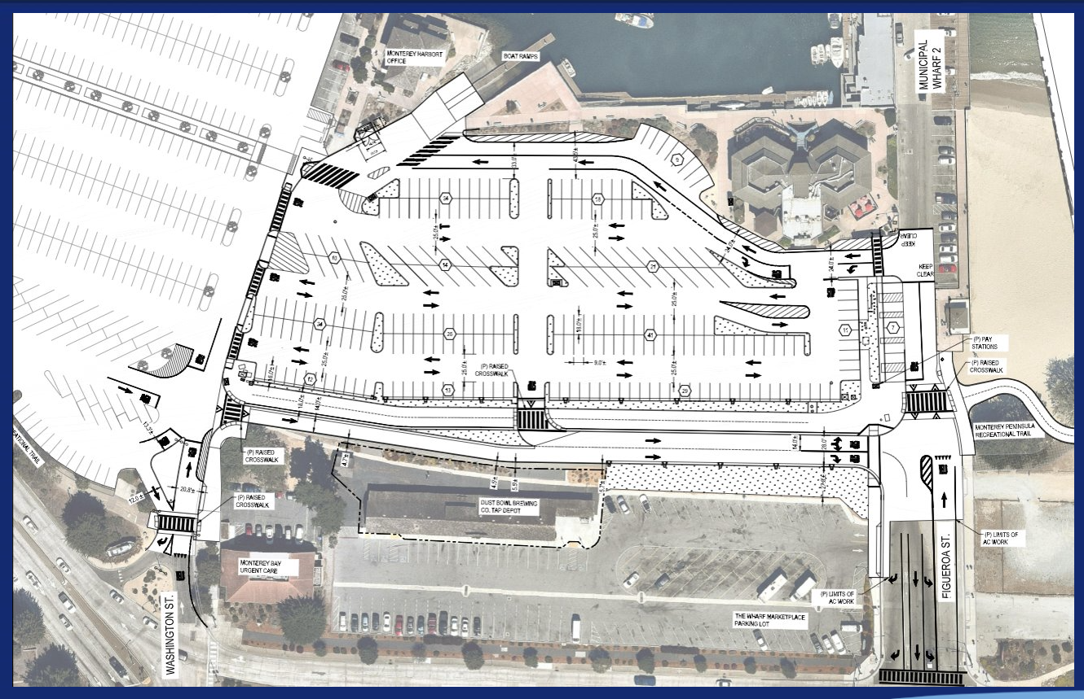*New Marina Lot Parking Layout*

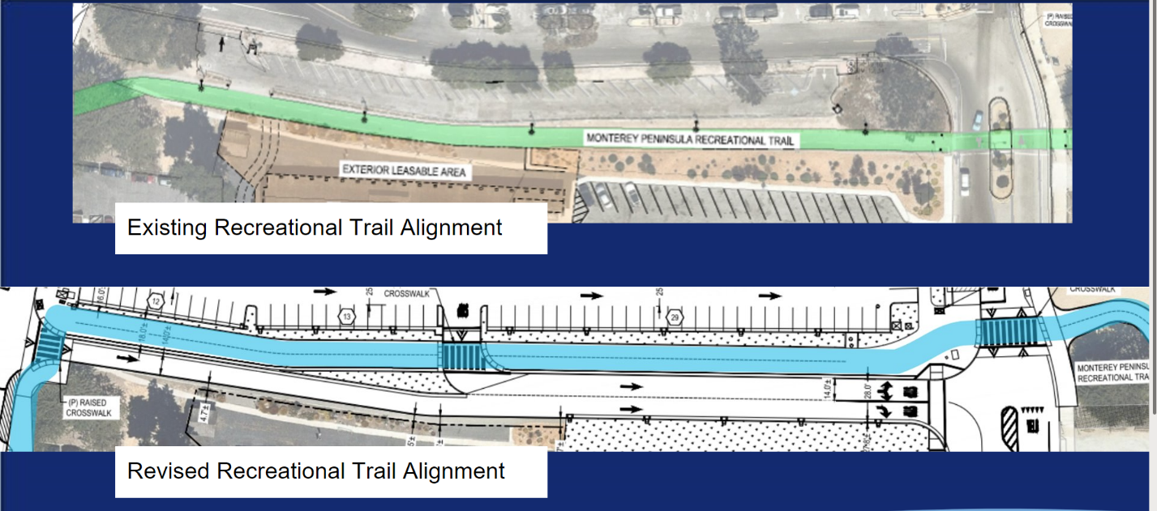  
*Recreation Trail Realignment Comparison Layout*

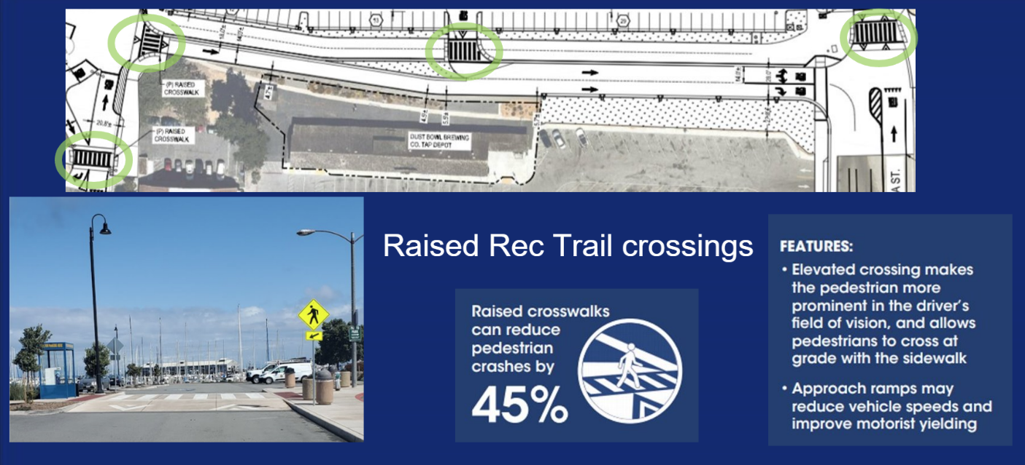  
*Recreation Trail Enhancements included Raise Recreation Trail Crossings*

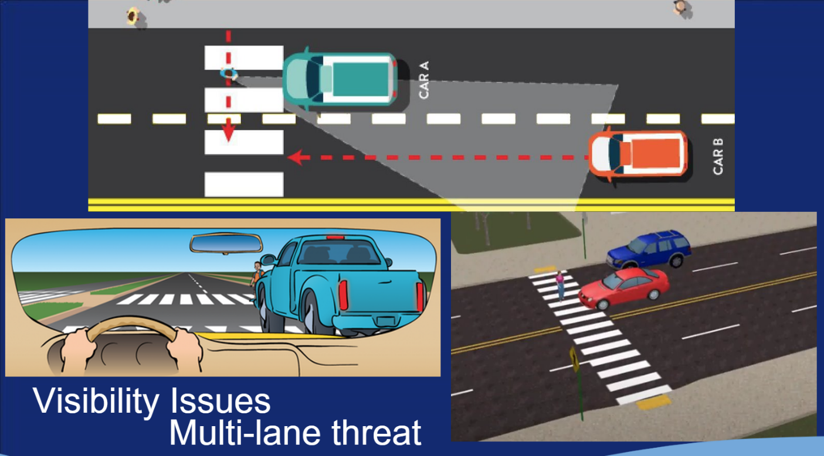  
*Examples of Multilane Threats*

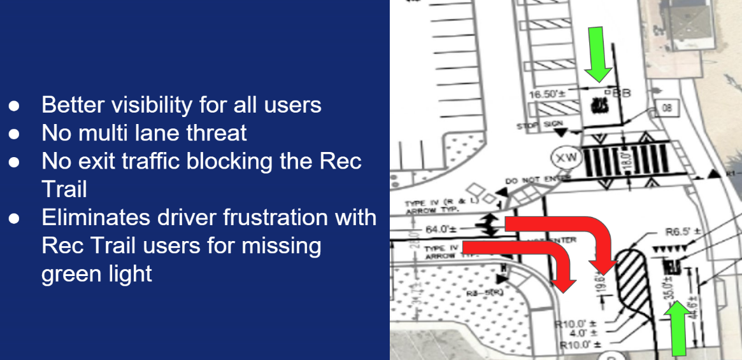  
*Improved Recreation Trail Crossing at Figueroa*

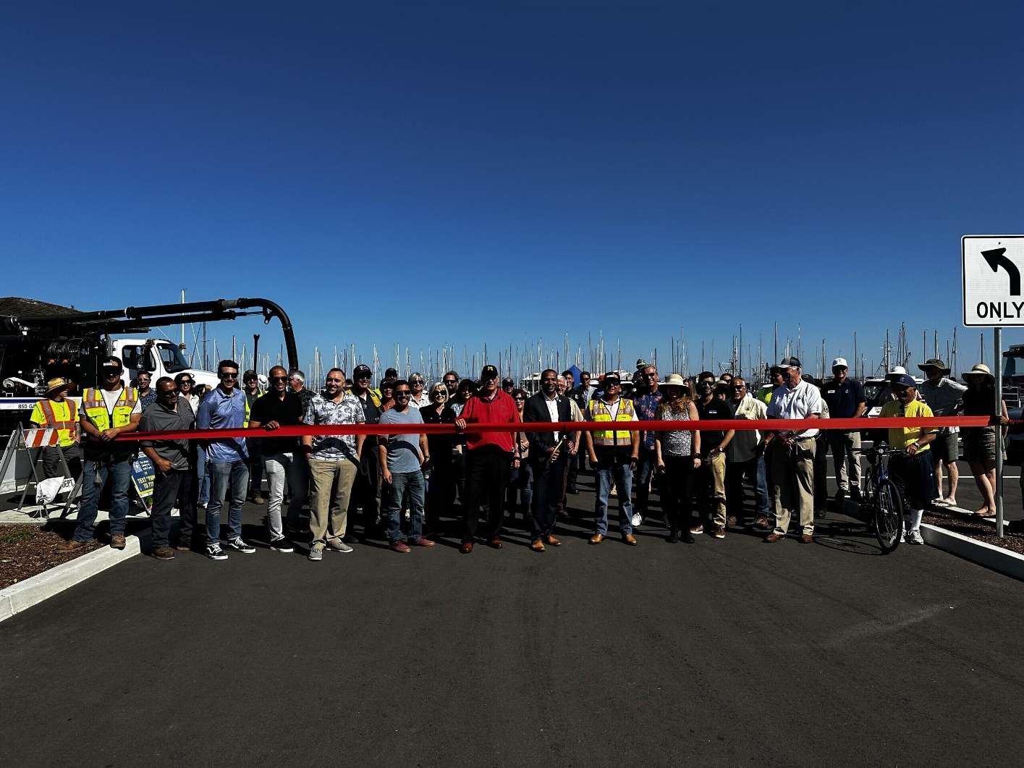  
*Marina Parking Lot Ribbon Cutting, October 2023*

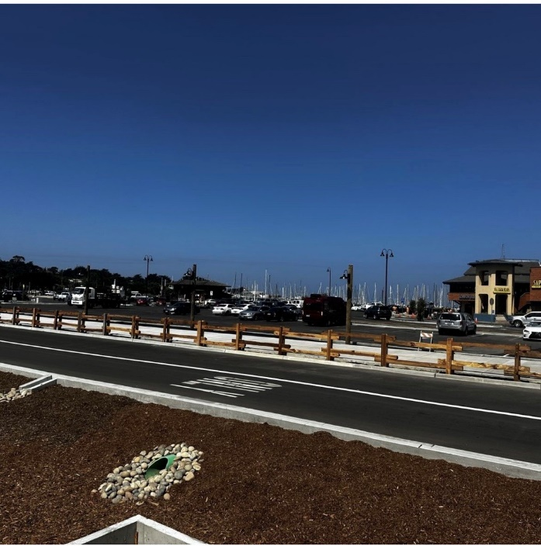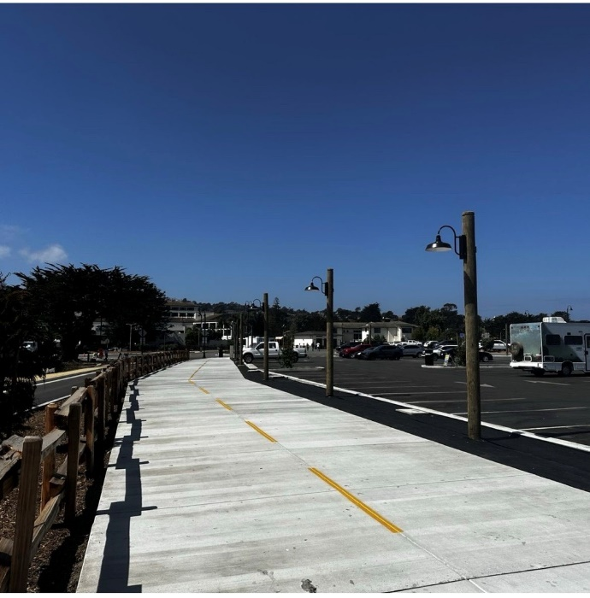

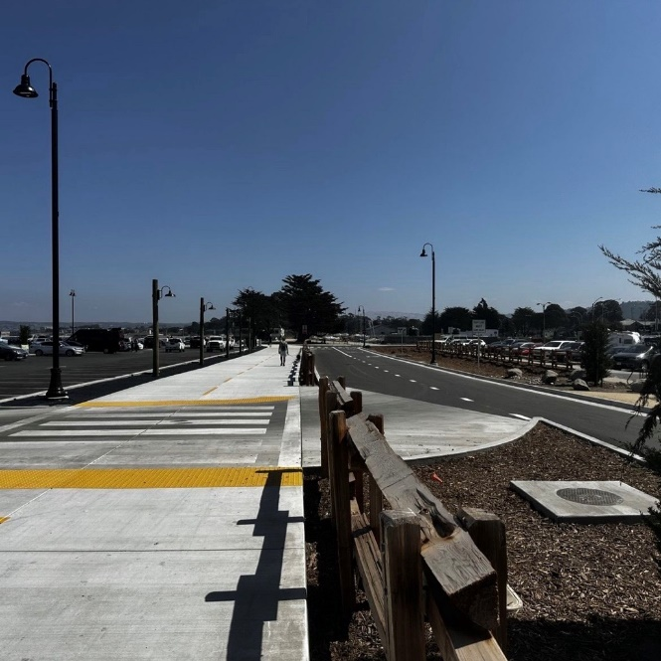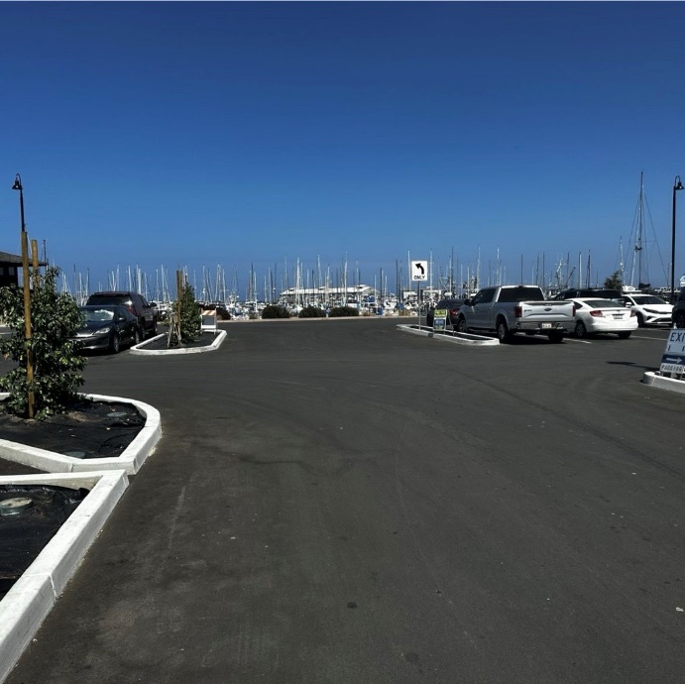

*Marina Parking Lot Improvements, 2023*