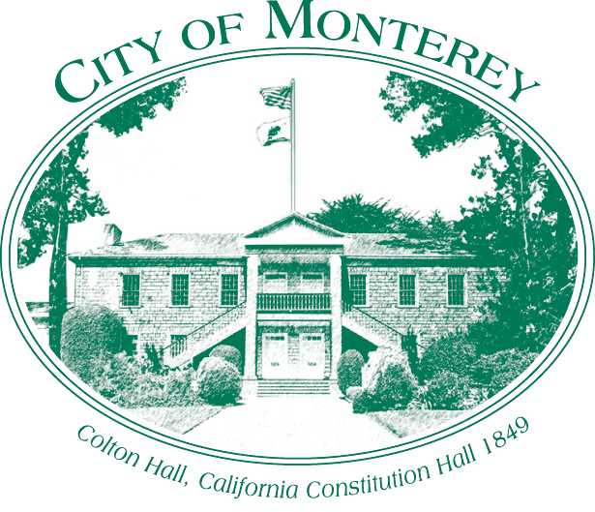

Measure X Project Report

December 2024

Measure X Transportation Projects

Abrego Street and Church Street Rectangular Rapid Flashing Beacon (RRFB) Installation Project

This project is the prime example of using Measure X funding to support transportation safety and operations improvements to enhance the quality of Transportation in Monterey and Monterey County.

## Project Description

Due to the high use of this intersection, particularly with higher volumes of pedestrians using this crosswalk for access in the Downtown Area. This is also an uncontrolled crossing, meaning a crossing where no traffic control (i.e. traffic signal or stop sign) is present. The project is an additional improvement replacing the non-compliant ADA Curb Ramps to include Rectangular Rapid Flashing Beacons (RRFBs).

IA 2017 Nationwide study reported a 47% reduction in pedestrian collisions as a result of installing a RRFB (Zegeer et al.). RRFBs are considered a proven countermeasure by the Federal Highway Administration (FHWA), which help address conflicts at crossing locations, pedestrian visibility, and compliance with yielding to pedestrians in crosswalks.

## Project Update

The project started in May 2023, but supply chain issues have impacted the procurement of materials. This has resulted in a delay of almost six months compared to past RRFB installation projects. This project was completed in April 2024.

## Project Funding

Account 1 (CIP2012) (MEASURE X): $47,500.00

Total: $47,500.00

## Before & After Photos

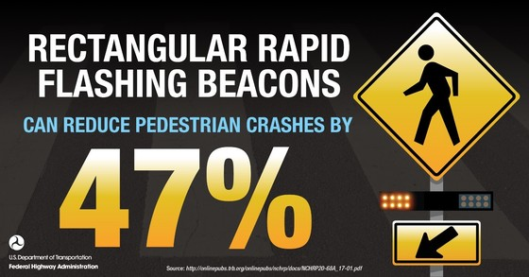 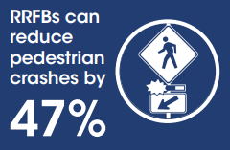

*FHWA Media on RRFBs*

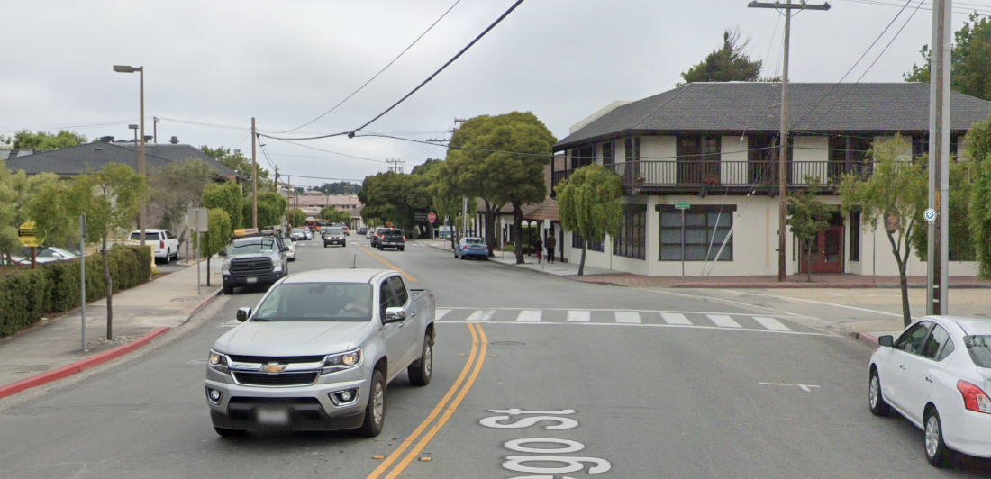

*Before Rectangular Rapid Flashing Beacon Installed, 2023*

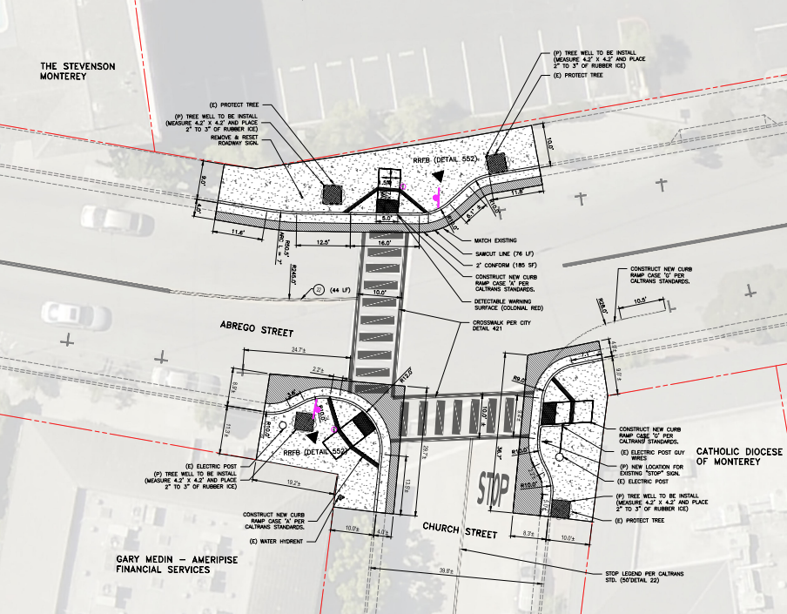

*Curb Ramp Improvement, 2023*

*Before Rectangular Rapid Flashing Beacon Installed, 2024*