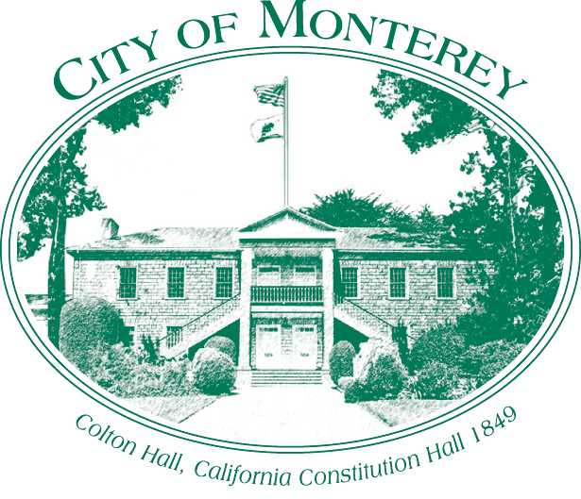

Measure X Project Report

December 2024

Measure X Transportation Projects

Flashing Beacon Replacement for Skyline Dr at Wyndemere Way

This project is the prime example of using Measure X funding to support transportation safety and operations improvements to enhance the quality of Transportation in Monterey and Monterey County.

## Project Description

This project was to replace a flashing beacon which provides warning to drivers on Skyline Drive at Wyndemere Way of the reverse curve ahead. A flashing beacon was implemented due to the rural characteristics and minimal street lighting. In April 2023, during one of the severe winter storms, multiple pine trees came down on Skyline taking down the sign and damaging a nearby controller cabinet.

## Project Update

The project was completed in January 2024. This is potentially eligible for reimbursement from FHWA and staff is hoping to be reimbursed for up to 75% of the cost.

## Project Funding

Account 1 (CIP2012)(MEASURE X): $11,650.00

Total: $11,650.00

## Before & After Photos

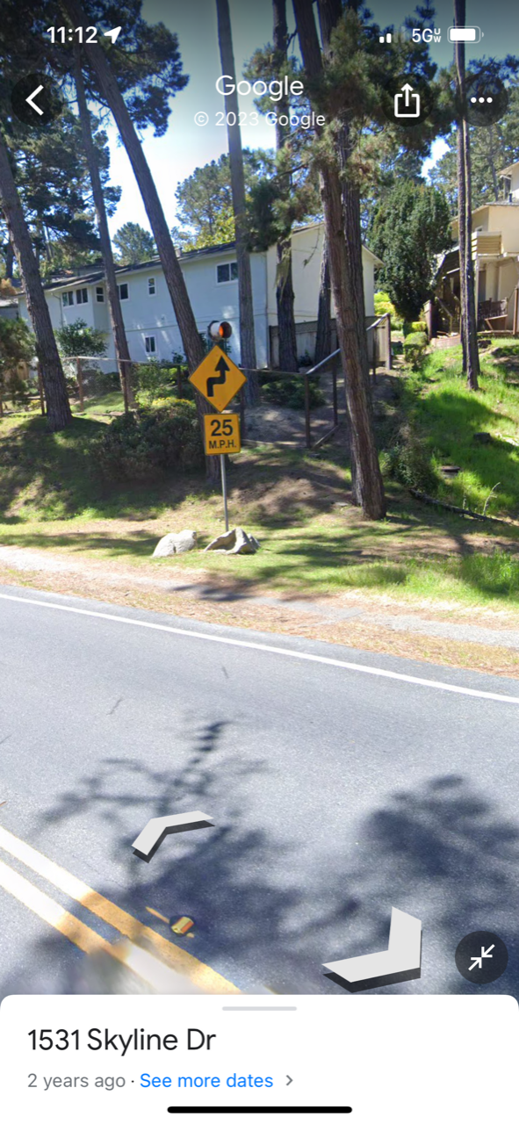

*Before*

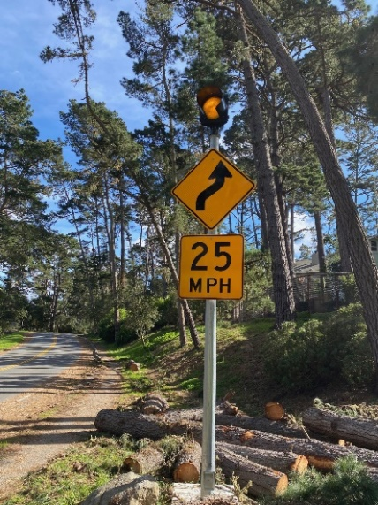 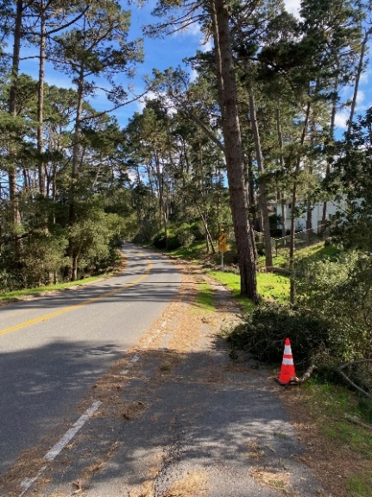

*After*